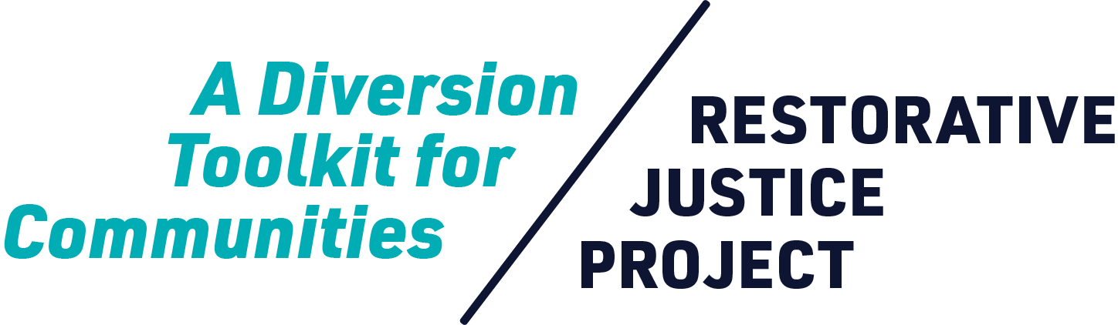



Worksheet

**Community Partner   
and Ally Landscape**

| What is a Community Partner and Ally Landscape?  Restorative justice relies first and foremost on relationships, so it’s important to know what organizations and groups in your county may be potential partners, allies, supporters, or resources for both your community-based organization (CBO) and the community members with whom you work.  Countywide support for this model of restorative justice diversion (RJD) means a lot more than just the implementation of a program. In order for the RJD program to thrive, it needs to be deeply rooted in and supported by community, so just as we encourage community building among individuals, we must also practice it as organizations. This means doing some research and getting to know the orgs that are already doing fantastic work with youth, their families, survivors of harm, or other community members who may align with the program and/or support for it.  The following categories are general areas in which organizations or groups working toward social justice and/or systemic change tend to operate. An organization may fall under a single category or multiple ones. As seen below, these areas of work are on a spectrum of achieving social and systemic change that ranges from addressing immediate needs as they exist in current power structures, to addressing the root causes that created those needs and organizing for direct actions that shift those power structures and lead to systemic change. |
| --- |

| Direct Service | A pre-charge, restorative justice diversion program falls into this category. It acknowledges the fact that youth of color are being over-criminalized and over-incarcerated by addressing the vast, immediate need to prevent more youth from entering the juvenile legal system. Other examples of direct service programs that address immediate needs are food banks or shelters. While direct service programs do not directly challenge power structures, they do fulfill the very real and urgent need to keep our youth safe and out of the system. They also provide people who have been harmed with an opportunity to heal and have their actual needs met in ways not currently possible in the traditional criminal legal system. |
| --- | --- |
| Self-help | Efforts that fall into the self-help category are usually those taken by communities to address a specific problem without necessarily engaging systems or services. Examples in this category are neighborhood crisis response teams or community clean-up/beautification projects. Self-help efforts stem from community members acknowledging that a problem exists and working together to address it in the short-term and typically on a case-by-case basis. |
| Education | It’s important to note that education (or the acquisition and disbursement of information) sits in the middle of the spectrum because it is inherently neutral. How we use both the acquisition and disbursement of knowledge in formal and informal ways (if we use them at all) dictates or leans toward meeting immediate needs or addressing root causes. Examples of education are: school and university courses and lectures, community informational sessions, such as “Know Your Rights,” etc. Additionally, so much of how we acquire or share information is now done via social media, so tweets, blogs, or facebook posts may also fall under this category. Lastly, some school districts currently using restorative justice approaches offer classes on restorative justice that are open to community. Local universities and community colleges also sometimes offer courses on restorative justice and other topics that can relate to this model of RJD. Churches may have study groups on the topic. It’s worth poking around to see if faculty or students may have an interest in data collection/analysis on topics such as racial and ethnic disparities in the criminal legal system, program/process evaluation, etc. |
| Advocacy | Advocacy is speaking or writing (typically to those in power) on behalf of others in support of a given cause or policy that does not necessarily directly affect those advocating for it. An example of advocacy is when individuals provide public comment at a county board of supervisors meeting in support of a policy that would allow for more alternatives to incarceration. These folks may or may not have participated in the creation of that policy, may or may not be a part of implementing it, and may or may not be affected by it. They are nonetheless publicly stating their support for it. Because this model of RJD requires the support of elected and appointed officials, advocacy groups can be hugely helpful in demonstrating to those in public office how desirable and beneficial RJD can be in your jurisdiction and to specific constituencies. |
| Direct Action | Community organizing happens when directly affected folks come together to identify the root systemic causes of a given problem in their community and design a plausible solution for it. This solution is often called an “issue cut.” Once an issue cut is identified and power mapping has taken place, a strategic plan is made for what can be done in order for that solution to be accepted by those in power and ultimately implemented. This plan will include various direct actions (such as letter writing or phone calls to decision-makers, marches/protests, public testimonies, etc.) that directly impacted folks can take in order to speak truth to power and have their solutions heard and realized. Examples of community organizing that may pertain to supporting this model of RJD are: campaigns for ending the criminalization of youth by way of policy changes, campaigns for divestment in the criminal legal system, and reinvestment into community programs. |

| No single category is better or more important than the other. Bringing about the change needed to end systems of oppression happens best when work is done in all of these areas simultaneously.  On the following page is a form that can be used to keep track of organizations and groups in your jurisdiction with which you may want to build relationships so that community awareness and support of restorative justice diversion can grow. Print or copy the form as many times as you need. Another reason to identify these potential allies is that, once your program is up and running, you can have a stronger network of support and services to offer participants in of your RJD program. |
| --- |

| Potential Partner or Ally? **Community-Based Organizations & Groups** |
| --- |

| **ORGANIZATION / GROUP NAME**: |  |
| --- | --- |

| **POINT OF CONTACT:** |  |
| --- | --- |

| **LOCATION:** |  |
| --- | --- |

| **SOCIAL / SYSTEMIC CHANGE CATEGORY(S):** |  |
| --- | --- |

| **ISSUE(S) / FOCUS AREA(S):** |  |
| --- | --- |

| **WHAT COMMUNITIES DO THEY SERVE AND WHERE?:** |  |
| --- | --- |

| **HOW CAN THEY SUPPORT RJD?:** |  |
| --- | --- |

| **DO THEY HAVE LEADERSHIP OF COLOR?:** |  |
| --- | --- |

| **DO THEY SUPPORT LEADERSHIP DEVELOPMENT IN COMMUNITY?:** |  |
| --- | --- |

| **DO WE HAVE AN EXISTING CONNECTION?:** |  |
| --- | --- |

| **WHAT IS OUR CONNECTION?:** |  |
| --- | --- |

| Potential Partner or Ally? **Community-Based Organizations & Groups** |
| --- |

| **ORGANIZATION / GROUP NAME**: |  |
| --- | --- |

| **POINT OF CONTACT:** |  |
| --- | --- |

| **LOCATION:** |  |
| --- | --- |

| **SOCIAL / SYSTEMIC CHANGE CATEGORY(S):** |  |
| --- | --- |

| **ISSUE(S) / FOCUS AREA(S):** |  |
| --- | --- |

| **WHAT COMMUNITIES DO THEY SERVE AND WHERE?:** |  |
| --- | --- |

| **HOW CAN THEY SUPPORT RJD?:** |  |
| --- | --- |

| **DO THEY HAVE LEADERSHIP OF COLOR?:** |  |
| --- | --- |

| **DO THEY SUPPORT LEADERSHIP DEVELOPMENT IN COMMUNITY?:** |  |
| --- | --- |

| **DO WE HAVE AN EXISTING CONNECTION?:** |  |
| --- | --- |

| **WHAT IS OUR CONNECTION?:** |  |
| --- | --- |