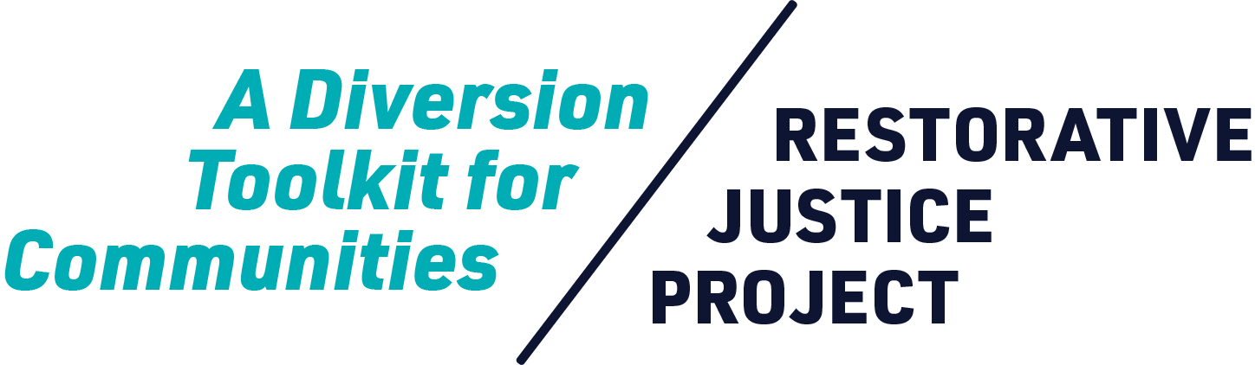



Worksheet  
**Establishing RJD Case and Participant Eligibility**

Establishing RJD Case & Participant Eligibility

**This worksheet should be filled out in collaboration between the facilitating community-based organization and the district attorney’s office.**

| **Types of Cases** | | **Instructions**: *Determine which types of cases and/or arrest types will be referred to the diversion program. Ensure that this corresponds with high arrest rates within the geographic region determined below.* | |
| --- | --- | --- | --- |
|  | | | |
|
| **Prior History** | | **Instructions:** *Determine whether or not responsible youth who have prior arrest history will be eligible to participate in the diversion program.* | |
|  | | | |
|
| **Dependency-**  **Delinquency Youth** | | **Instructions:** *Determine whether or not dependency/delinquency/crossover youth (this refers to youth who are involved in foster care system) will be eligible to participate in the diversion program.* | |
|  | | | |
|
| **Age of Youth Who Caused Harm** | | **Instructions:** *Determine what are the minimum and maximum ages for responsible youth to participate in the diversion program.* | |
|  | | | |
|
| **Zip Codes/Geography** | | **Instructions:** *Determine the geographic region where cases will be referred from. This can be limited by zip code. Ensure that this corresponds with high arrest rates of the case types determined above with high racial and ethnic disparities.* | |
|
|  | | | |
|